**Leader Overview**

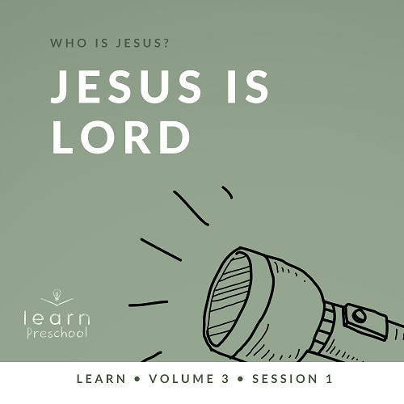

**Volume Overview**

**Who is Jesus?**

*In the classic book* Mere Christianity*, C. S. Lewis reasoned that those who refuse to believe Jesus’ claim to be God are left with the option of labeling Him as a lunatic or the devil. Jesus asked His closest followers who people thought He was (*[*Matthew 16:13*](https://ref.ly/logosref/Bible.Mt16.13)*). The disciples responded with far-ranging opinions. But then Jesus turned the question on them: “Who do you say I am?” Two thousand years later, there may not be a more important question for any of us to answer*.

**Session Overview**

**Jesus Is Lord**

*In this* **Learn** *session, preschoolers will discover that Jesus is Lord. In our Bible story, Jesus arrived in Jerusalem riding on a donkey, and the people greeted Him by shouting praises. Your preschoolers will learn that it’s exciting to praise Jesus with their words and actions as they follow Him*.

**Bible Lesson**

Jesus’ Triumphal Entry

[Mark 11:1–11](https://ref.ly/logosref/Bible.Mk11.1-11)

**Faith Fact**

I will follow Jesus.

**Faith Verse**

[John 3:16](https://ref.ly/logosref/Bible.Jn3.16) (NLT)

“For this is how God loved the world: He gave his one and only Son, so that everyone who believes in him will not perish but have eternal life.”

**Preparing for the Session**

**Leader Preparation Time: 20–25 Minutes**

|  |
| --- |
| ***You Will Need***  ***Preservice Activities***  *• Green construction or copy paper, one sheet per kid*  *• Scissors, multiple pairs for kids to share*  *• Tape*  *• Wrapped candy*  ***Large Group***  *• Bible*  *• Optional: Preservice craft palm branches*  *• Worship songs (Song suggestions: “Praise the Lord Every Day” by Yancy, “Hosanna” by Yancy)*  *• For groups not using a phone or tablet only, add:*  *• Projector or TV*  *• Laptop*  *•* ***Faith Fact Sound video*** *(bell ringing)*  *•* ***Faith Fact Slide***  *•* ***Faith Verse Slide***  *•* ***Bible Lesson Video A***  *•* ***Bible Lesson Video B***  ***Small Group***  *• Small Group Connection pages*  *• Palm branches from the Preservice Activities*  *• Scissors*  *• Tape*  *•* ***Small Group Activity Page****, one per kid*  *• Crayons or markers*  *• Bubbles and wands*  *To access session content and videos from a computer, visit:* [*BibleEngagementProject.com/downloads*](https://bibleengagementproject.com/Downloads) |
| ***Getting Ready***  ***Preservice Activities***  *• Set out toys and snacks.*  *• Roll paper from the shorter edge into approximately 1-inch tubes and tape near the edge on one end only, one per kid.*  ***Large Group***  *• Download videos and slides if needed.*  *• Select worship song(s) and have them ready to play.*  ***Small Group***  *• Print and cut out each banner from the* ***Small Group Group Connection*** *pages.*  *• Tape banners #1–5 in different places around the room.*  *• Print copies of the* ***Small Group Activity Page****, one per kid*  *First time leading* Learn *for Preschool? Check out the* [Facilitator Guide](https://0b769b0ed3569ef9d18b-f88d8272f61086866d50d048b43ef630.ssl.cf2.rackcdn.com/sites/biblengagementproject/Listen_Facilitator_Guide.pdf)*.* |

**Preservice Activities**

*See what’s needed at the beginning of the session.*

**Bible Story Warm-Up**

Today, our Bible story is about a very special time Jesus came into a city. We can think about it kind of like a parade. It’s fun to see a parade. It’s fun to be in one, too.

• *Ask these questions*.

Have you ever been to a parade or watched one on TV?

What do you remember about the parade?

Did you see people in the parade wave? Let’s do that together. *(Group response)*

• *Give kids the paper tubes and scissors*.

In our Bible story, people cheered and waved branches from palm trees as Jesus passed by. Let’s make branches for our own parade to worship Jesus.

• *Have the kids cut 4 or 5 straight lines halfway down the tube from the untaped end*.

• *Gently pull out the inside strips until the “branches” flare out*.

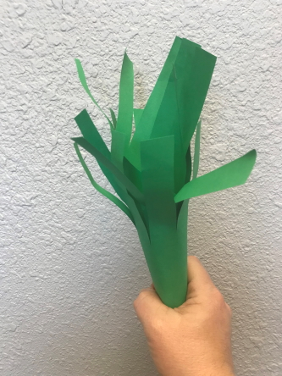

**Snack**

**Wrapped Candy**

Sometimes people in a parade give candy to people who are watching. Have you ever caught candy at a parade? *(Group response)*

• *Give a few pieces of candy to the kids to eat*.

I’m looking forward to finding out more about the time Jesus came to town and it was like a parade. I hope you are, too.

**Free Play**

*Any extra time can be spent playing with toys*.

**Transition**

*A few minutes before service begins have kids make their way to the large group area and sit in their designated areas*.

**Large Group**

**25 Minutes**

*See what’s needed at the beginning of the session.*

**Introduction**

Welcome, everyone! I love how you’re sitting in your spot ready to learn about Jesus with me. This is the part of our time together when we get to learn from God’s Word, the Bible. The Bible tells us about Jesus. Today, we’ll learn about when Jesus rode into town on a donkey like a special parade. People cheered for Jesus as He rode by. They wanted to follow Him.

**Faith Fact**

We can choose to follow Jesus, too. I want to do that. How about you? *(Group response)* That’s why our Faith Fact for today is **I will follow Jesus**.

• *Show the* ***Faith Fact Slide***.



Let’s stand up and march while we say it. **I will follow Jesus.** Keep marching. Can you shout it? **I will follow Jesus.** Let’s wave our hands in praise. **I will follow Jesus**.

**Bible Time**

Hey, let’s check in with our friend Lizzy. Maybe she’ll tell us more about the parade for Jesus.

• *Play* ***Bible Lesson Video A***.

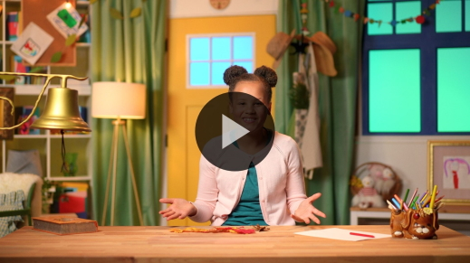

Wow, friends! Lizzy told us how Jesus came into Jerusalem riding on a donkey. Would you like to ride a donkey like He did? *(Group response)* What did the people do as Jesus passed by? *(Allow responses.)*

**Worship**

Lizzy told us how some people might have worshipped Jesus in a big way and some worshipped Him just a little. Let’s worship Jesus with our whole heart.

**Praise**

We’re going to praise Jesus just like the kids did when Jesus came by on the donkey. Are you ready? Here we go! Let’s give Him praise.

Wave your hands and say, “Praise Jesus!”

Hug yourself and say, “Jesus loves me!”

March and clap and say, “I will follow Jesus!”

Jump up and say, “Hosanna!”

Spin around and say, “Hallelujah!”

**Sing**

The people celebrated Jesus when He rode the donkey into Jerusalem. Let’s celebrate Jesus with singing.

• *Lead the kids in singing one or two songs. See song suggestions at the beginning of the session*.

• *Optional: Wave the palms branches made in Preservice Activities with at least one of the songs. You might say, “Let’s use our palms branches like the children did to celebrate Jesus is Lord with this song.” If you have room, you might even make a parade to finish the worship and shout, “I will follow Jesus.”*

**Prayer**

You did a great job worshipping Jesus. He loves it when we do that. Earlier Lizzy reminded us how Jesus had healed people in different ways. Let’s thank Him for doing that.

Touch your legs and say, “Jesus, thank You for healing people’s legs.”

Touch your eyes and say, “Jesus, thank You for healing people’s eyes.”

Touch your ears and say, “Jesus, thank You for healing people’s ears.”

Touch your heart and say, “Jesus, thank You for healing people’s hearts.”

Has Jesus healed you before? Maybe you got hurt or got sick. Maybe you hurt somewhere right now, and you need Jesus to heal you. Touch the spot on your body that you want to pray for right now. *(Pause for kids to respond)* Let’s pray.

• *Have the kids repeat phrases after you*.

|  |
| --- |
| Dear Jesus, thank You for creating me. Thank You for healing me. I love You. Amen. |

**Bible Time cont’d**

That was wonderful! Now, find your spot again. It’s time to check back in with Lizzy and Grandpa.

• *Play* ***Bible Lesson Video B***.

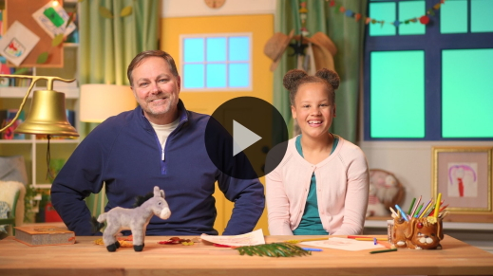

I’m so glad Lizzy and Grandpa are teaching Bible verses to us. You did a great job learning our Faith Verse. Did you know it’s one of the best-known verses in the whole Bible? *(Group response)*

**Response Time**

• *Play a worship song quietly*.

Our Faith Verse tells us how much love God showed to everyone in the whole world. Let’s thank God for loving us so much and for sending His Son, Jesus. Pray with me.

• *Optional: Have the kids repeat phrases of the prayer after you*.

|  |
| --- |
| Dear God, thank You for sending Jesus. Thank You for loving us. We love You. We praise You. We want to follow You. Amen. |

**Faith Verse**

Let’s say our Faith Verse together one more time.

[John 3:16](https://ref.ly/logosref/Bible.Jn3.16) (NLT)

“For this is how God loved the world: He gave his one and only Son, so that everyone who believes in him will not perish but have eternal life.”

• *Show the* ***Faith Verse Slide***.

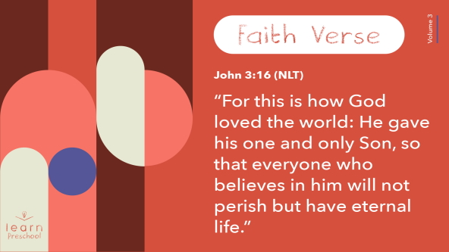

Let’s say it and do the actions. We’re just working on the first part of the verse today.

**John** *(hands at waist, spread apart, palms up and out)*

**3:** *(hands together like a clap)*

**16** *(hands opened to “book”)*

**“For this is how God** *(two index fingers point up)*

**loved the world:** *(two hands covering heart)*

**He gave his one and only Son**, *(hold up one finger)*

You’re so awesome! You’re doing such a good job learning our Faith Verse.

**Closing**

Today has been a special day because we came to celebrate Jesus.

• *Play the* ***Faith Fact Sound*** *video (bell ringing)*.

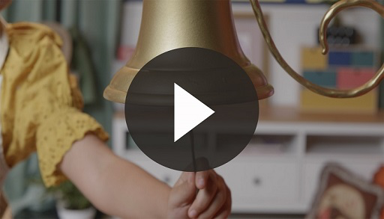

• *Show the* ***Faith Fact Slide***.



What’s that sound? It’s our Faith Fact sound. Are you ready to march? Let’s march and say our Faith Fact. **I will follow Jesus.** Now, wave your hands in praise. **I will follow Jesus**.

**Dismissal to Small Groups**

Great job! Now, it’s time to go to our circles where we’ll spend time in our very special small groups.

• *Dismiss the kids by groups*.

|  |
| --- |
| ***Leader Tip:*** *This can be done by assigning color teams or by age groups. Note that some young preschoolers may not know their age. Using a colored sticker, jersey, or wristband will help separate the kids and help identify their small groups.* |

**Small Group**

**25 Minutes**

*See supplies and prep instructions at beginning of session or in each activity below.*

|  |
| --- |
| ***Leader Tip:*** *Small groups can alternate to each circle, or all groups can do each activity at the same time. If you choose to alternate, you will need at least one leader per circle.* |

**Circle 1**

**Group Connection**

**Praise Parade**

|  |
| --- |
| ***You Will Need***  *•* ***Small Group Group Connection*** *pages*  *• Palm branches from the Preservice Activities*  *• Scissors*  *• Tape*  ***Getting Ready***  *• Print and cut out each banner from the* ***Small Group Group Connection*** *pages.*  *• Tape banners #1–5 in different places around the room.* |

Who can tell me today’s Faith Fact? *(Group response)* Say it with me. **I will follow Jesus.** Today, we’ll have a praise parade. It’s a celebration like when Jesus rode the donkey into Jerusalem.

• *Choose a kid to carry the Praise Parade banner at the front of the line*.

• *Optional: Have kids wave the palm branches they made in Preservice Activities*.

We’re looking for the banner that has the number 1 on it. Are you ready to follow me to find it?

• *At banner #1, read the motion and praise words. Have the kids do the action and praise Jesus*.

Now, let’s continue our praise parade until we’ve been to all five stops.

• *Optional: Choose a new kid to carry the Praise Parade banner to the next stop*.

That was awesome! Now that we’ve finished our praise parade, let’s say our Faith Fact one more time. **I will follow Jesus**. Thanks so much for being in our praise parade.

**Circle 2**

**Activity Page Time**

**People Praise Jesus**

|  |
| --- |
| ***You Will Need***  *•* ***Small Group Activity Page****, one per kid*  *• Crayons or markers*  ***Getting Ready***  *• Print copies of the* ***Small Group Activity Page****, one per kid.* |

The people used palm branches to wave when they praised Jesus. Let’s color the picture of Jesus riding into Jerusalem.

• *Hand out the* ***Small Group Activity Page*** *and crayons or markers.*

How do you think the kids felt when they waved their branches in praise?

Do you wish you could have been there to praise Jesus?

What would you have said to Jesus as He passed by?

• *During the activity, interrupt and practice the Faith Fact:* ***I will follow Jesus***.

• *Play* ***Faith Fact Sound*** *video. Review the Faith Fact even if you can’t play the sound*.



**Circle 3**

**Feet-to-Floor Game Time**

**Follow the Leader**

What’s our Faith Fact today? *(Group response)* **I will follow Jesus.** Our game will help us practice following. It’s called Follow the Leader.

• *Have kids stand in a circle facing each other*.

The leader will say the Faith Fact and choose actions for us to follow. We’ll say the Faith Fact and do the same actions. We need to do everything exactly like the leader does. Then, the next person in the circle gets to be the leader. Let’s give it a try.

• *Encourage each leader to do a variety of motions and movements. They can make hand gestures, skip, march, jog, dance, etc. Have fun with it*.

• *Keep playing, allowing every kid in your group to be leader if you have time*.

Good job of following! I want you to follow Jesus closely every day.

**Circle 4**

**Hands-On Learning**

**Bubbling Praise**

|  |
| --- |
| ***You Will Need***  *• Bubbles and wands*  *No prep needed for this activity.* |

What’s your favorite way to worship Jesus? *(Group response)* There are many praise words that we can say to Jesus. Let’s say some together.

• *Have the kids repeat praise words: Praise You, Jesus; I love You, Jesus; You are great; I will follow You, etc*.

Now let’s blow bubbles and praise Jesus together. Choose one or more of the praise phrases we just said to say to Jesus as we celebrate with bubbles.

• *Have the kids stand up. Encourage them to praise Jesus and celebrate Him as they or you blow bubbles*.

**Dismissal**

• *Play* ***Faith Fact Sound*** *video (bell ringing).*



• *Show the* ***Faith Fact Slide***.



I can’t believe it’s time to go already. Let’s say the Faith Fact together one last time. **I will follow Jesus**. Great job! I had a great time learning more about Jesus with you. See you next time.

• *Send home the* ***Small Group Activity Page*** *with each kid*.

• *Remind parents that there are* ***Family Devotions*** *available on the app to do with their kid*.

• *Tell everyone the date and time for the next session*.